**Today’s Topic:**

***Java and Open JDK installation:***

**Step1**: To run selenium/simple java program, java is required and why java is required?

**Important point:** After the release of Java 11, Oracle has changed its license terms. So there will be two versions of Java. One is Standard commercial version and the other is open JDK. You cannot use the commercial version in your production environment but can be used in development and testing purposes.

a) Writing a selenium test cases using Java has multiple benefits: Selenium supports Java. So, testers can leverage the active community of contributors and detailed documentation to write test cases. Programs written in Java are faster than other popular languages like Python etc.

**Note** : Selenium is an open source automation testing tool that supports a number of scripting languages like C#, Java, Perl, Ruby, JavaScript, etc. Depending on the application to be tested, one can choose the script accordingly.

**Java Installation link:**

<https://www.oracle.com/in/java/technologies/javase/jdk11-archive-downloads.html>

Step : Click on next button once you double click on exe file from downloads

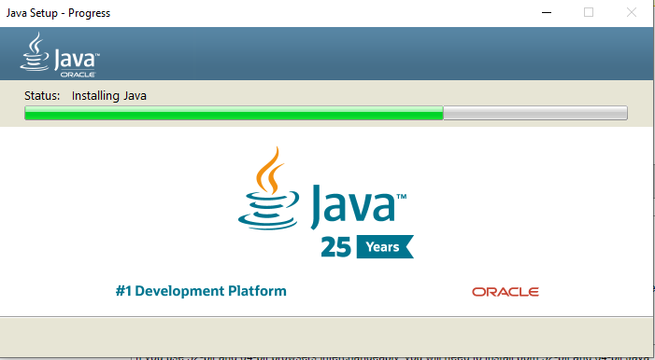

Step2: Once installation got completed , Then Open Command Prompt

And Type: **Java –version**

**@Open JDK for Selenium**

**What is it:** For Open JDK, Oracle will not provide support & updates? You have to update to new version whenever a new version is available.

Goto: <http://jdk.java.net/archive/>

2nd step :

1. Now, It is time to set the environment variable to complete the installation. Go to your computer and do a right click. From the menu options, select the properties link.

Imp info: Environment **variables are useful to store system-wide values, for examples, PATH**

Why: The PATH variable prevents us from having to write out the entire path to a program on the CLI every time we run it. Essentially, it's just a variable that stores a bunch of shortcuts. When you enter a command on the CLI without using the absolute path, the operating system checks the PATH variable.

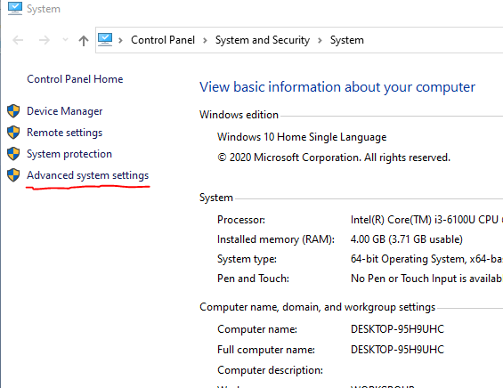

2. Click on the advanced system settings in the opened window.

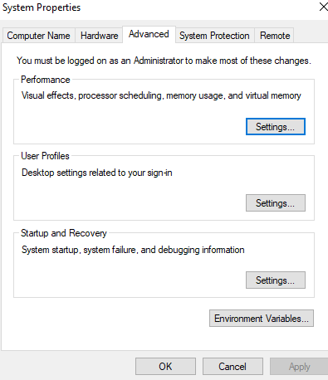

3. Once the Advanced system settings link is clicked, another system properties pop up window will open. Click on the Environment variables in that window.

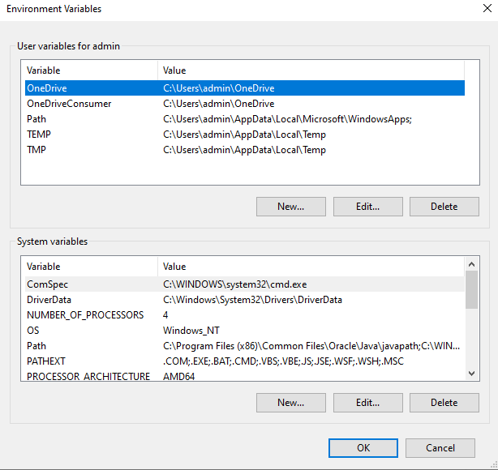

4. Click on new button

5. Now add the Variable name as ***JAVA_HOME***. Since I have extracted the zip file in downloads folder, I will add Variable value as ***C:\Users\admin\Downloads\jdk-15.0.1***

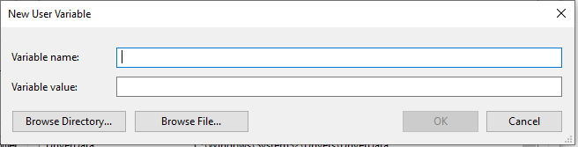

6. Now, we need to add the ***path*** variable with bin folder path in JDK. Click again the New button under user variables. Now add the Variable name as path. And add Variable value as ***C:\Users\admin\Downloads\jdk-15.0.1\c***

7. Then click on Ok button. Now you have successfully installed the open JDK. Now it is time to quickly check if you have installed Java correctly. Open the command prompt and type ***java -version***

8. You should be getting the output as javac 11.0.1.

**Eclipse Download:**

<https://www.eclipse.org/downloads/packages/release/2021-06>

Steps : Click on above link

Step 2: click on download button

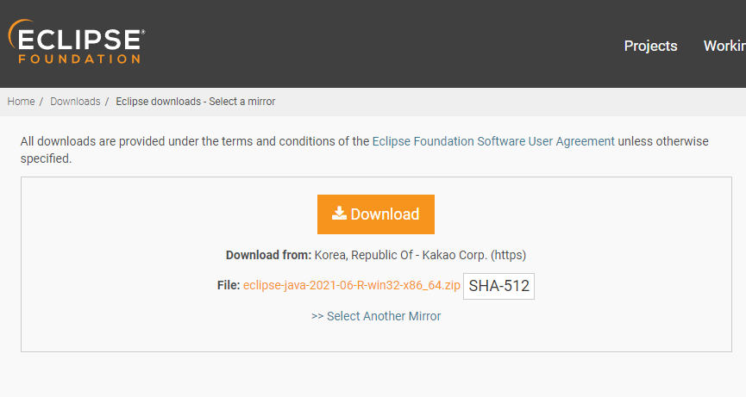

Step 3 : Click on Download

Once download got completed then run it.

Step 4. Select "Eclipse IDE for Java Developers" IDE option from the list.

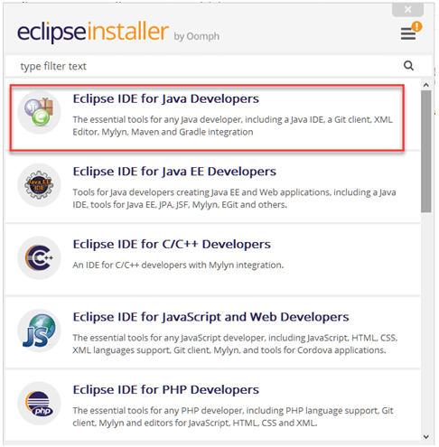

Step 5: After that, a new window will open which click button marked 1 and change path to "C:\eclipse". Post that Click on Install button marked 2

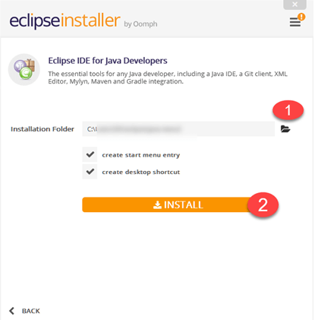

Next step is :

